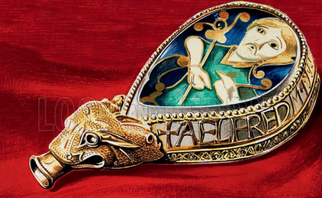

Was Alfred Great?

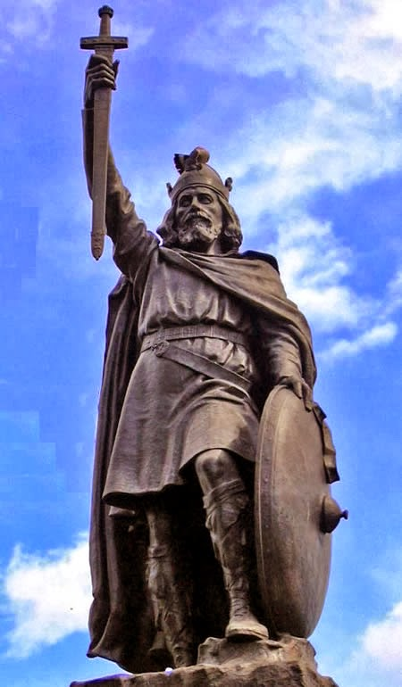

This term we are going to be learning about King Alfred, the Anglo Saxon king. To help us better understand what life was like for people of this time. We would like you to find out what the Anglo-Saxons ate and drank, create a menu for an Anglo-Saxon feast, find a recipe for an Anglo Saxon dish and recreate it for us all to try on our Anglo Saxon day on Thursday 14th February

**Steps to Success**

1. Draw and label the crops and vegetables the Anglo Saxons farmed.
2. Draw and explain what the Anglo Saxons used animals for.
3. Use the crop and animal information you have gathered to design and present a menu for an Anglo Saxon feast.
4. Investigate and write up an Anglo Saxon recipe you would like to make and share with all of us. (please ensure that you include the recipe to allow any the allergies and religious needs to be taken in to consideration)
5. Gather the ingredients that you need to make your recipe.
6. Bring your Anglo Saxon food in to share as part of our Anglo Saxon day.

**Hints and Tips**

To help you research, try these websites:

<https://www.historyhit.com/anglo-saxon-food-and-drink/>

or

<http://cookit.e2bn.org/historycookbook/index-28-saxons-vikings.html>

**Due Date on outcome day**

**Thursday 14th February**